Questionnaire

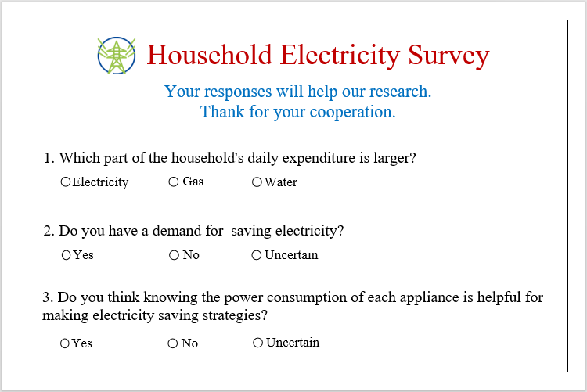

Statistical results

100 families have been surveyed.

1. Which part of the household’s daily expenditure is larger?
2. Do you have a demand for saving electricity?
3. Do you think knowing the power consumption of each appliance is helpful for making electricity saving strategies?